SECURE FILE STORAGE SYSTEM WITH ENCRYPTION AND ROLE-BASED ACCESS CONTROL (RBAC)
Methodology, Novelty and Key Contributions
Department of Computer Science and Engineering, TKR College of Engineering & Technology
Batch C13 (CSE-C) · Academic year [ACADEMIC YEAR]
Table 1: Project team
S.No. | Student name | Roll number
1 | Pramod Reddy Yalala | 23K91A05J9
2 | Pendela Vyshnavi | 23K91A05J1
3 | Luke Abraham Sam | 23K91A05D4
4 | Mudavath Suresh | 23K91A05G2

Project guide: D V V Deepthi
Chapter and section numbers quoted in the text (for example Chapter 8 or Section 6.2) refer to the full project report, 17.Final Document. Figures and tables in this document are numbered from 1.

1. METHODOLOGY
This document describes how CipherVault works from end to end and what is new in it. Part 1 gives the pipeline, the data, the algorithms and the reasons they were chosen; Part 2 sets the work against the base paper and separates what is new from what is standard; Part 3 lists the contributions.

1.1 Overall methodology
CipherVault is built by the following method: decide who must be trusted with which secret, give each secret to exactly that party, express the decision in a small number of standard primitives, and then measure what the decision costs and what it still fails to protect. The base paper [1] solves a related problem for health records with attribute-based encryption, a permissioned blockchain and a language model that extracts attributes from clinical notes, and evaluates it by calculation from primitive timings. The closest architecture in the literature, the cloud file store of Sowmiya et al. [2], uses client-side AES, RSA key management, role-based access control and a signed audit log, and reports an evaluation with 50 users in three roles. CipherVault keeps the shared aim (the storage provider never holds readable content, access is role-based and every action is recorded) and replaces the heavy machinery by a design that one browser, one small server and a standard library can run. No model is trained, so the methodology is a protocol design plus a measurement protocol. The protocol has eight steps.
1. Register. The browser generates an RSA-2048 key pair, derives a key-encryption key from the password with PBKDF2, seals the private key with AES-256-GCM and sends the public key, the sealed bundle and the password; the server stores a bcrypt hash, not the password.
2. Authenticate. The server checks the bcrypt hash, applies the login throttle, issues a JWT valid for 120 minutes and records the event; the browser fetches the sealed bundle and unlocks the private key in memory.
3. Encrypt and upload. The browser hashes the file with SHA-256, draws a random 256-bit file key and a 12-byte IV, encrypts with AES-256-GCM, wraps the file key with the owner's public key and uploads ciphertext, IV, wrapped key and digest.
4. Store. The server validates the fields, writes the ciphertext under a random 32-hex name, inserts one metadata row and appends an audit entry.
5. Share. The owner's browser unwraps the file key, wraps it again for the recipient's public key and posts the result with the role (viewer or editor); the server stores it in a permission row.
6. Retrieve. The server resolves the caller's role, returns the ciphertext with the IV, the caller's own wrapped key and the digest, and audits the download; the browser unwraps, decrypts, checks the AES-GCM tag and compares the SHA-256 before saving.
7. Account. Every sensitive action, success or refusal, appends an entry to a hash chain; any signed-in user can ask the server to recompute the chain.
8. Measure. Time every primitive in the browser, every endpoint over loopback and the whole pipeline end to end; test the access matrix, forged tokens and tampering on the live system; record what fails (Chapters 7 and 8).

1.2 Dataset
CipherVault uses no dataset in the machine-learning sense. A file store has no training data, no labels and no train-test split, and for that reason it has no accuracy, precision or F1 to report. Two kinds of data appear in this work, and both are synthetic. The first is the demo data: three fictional accounts and five small files created by the one-click demonstration login (frontend/src/lib/demo.js) through the normal API and the normal browser encryption, so that every screen of the application can be shown with real, populated records. The second is the measurement workload: random byte strings of fixed sizes and throw-away accounts created by scripts/measure_metrics.py on a scratch database, so that no figure depends on the content of a file.
Table 2: Data used in this work.
Item | What it is | Size and origin
Demo accounts | owner@example.com, editor@example.com and viewer@example.com, with fictional names | 3 accounts; real RSA-2048 key pairs generated in the browser; example.com is a reserved documentation domain
Demo files | Q3-board-memo.txt, regional-revenue.csv, api-credentials.json, employee-handbook-draft.md, design-review-notes.txt | 5 small synthetic text files; shared as editor or viewer in the pattern defined in demo.js
Crypto timing workload | Random buffers encrypted, decrypted and hashed by the browser's Web Crypto API | 1 KiB, 64 KiB, 1 MiB, 10 MiB and 25 MiB; 50 to 4 repetitions per size
Pipeline workload | Encrypted and plain upload and download of random buffers from the browser to the same endpoint | 1 KiB (30 reps), 1 MiB (20 reps) and 10 MiB (15 reps)
API workload | Upload and download of random ciphertext of fixed sizes through the REST API | 1 KiB to 25 MiB less 2 KiB; 20 to 3 repetitions
Access-control workload | One file, four principals (owner, editor, viewer, stranger), nine operations | 36 cells, each compared with the expected decision
Audit workload | The hash chain of the measurement database, copied and altered in nine ways; chains of up to 5000 entries | 461 entries available for the tamper study; 199 to 200 trials per class
Training data | None: no model is trained or fine-tuned | -

Three properties of this data shape every result. The files are small and random, so a figure describes the cost of the cryptography and of the server and says nothing about a user's real documents, whose compressibility, type or sensitivity has no effect on the timing. The user population is three fictional accounts, so no result describes behaviour with many users. And the host was an ordinary desktop that other jobs were also using, so all timings are indicative and are reported with their 95th percentiles; the values and their spread are discussed in Chapter 8. The base paper [1] likewise reports no dataset and no extraction accuracy for its language-model step, and the paper of Sowmiya et al. [2] describes a 50-user evaluation without giving its data, so neither provides numbers that can be re-computed here.

1.3 Preprocessing
In a file store, preprocessing is everything that happens to a file in the browser before a single byte leaves it, plus the validation that the server applies to what arrives. The client part is in frontend/src/lib/vault.js (uploadFile) and is the same for the demonstration, the tests and the real interface.

1.3.1 Client-side steps
1. Size and emptiness check. The browser reads max_upload_mb from /api/config and refuses a file larger than 25 MB or of zero bytes before any cryptography runs.
2. Read. The whole file is read into one ArrayBuffer; there is no chunking, which is why the size limit exists (Section 6.11).
3. Digest. crypto.subtle.digest('SHA-256') over the plaintext gives a 64-character hexadecimal string.
4. File key. generateKey creates a random 256-bit AES-GCM key, the file-encryption key (FEK), for this file only.
5. Encryption. crypto.getRandomValues draws a 12-byte IV and encrypt returns the ciphertext with the 16-byte tag appended, so the stored object is exactly 16 bytes longer than the plaintext in every size measured.
6. Wrapping. wrapKey('raw', ...) encrypts the FEK with the owner's RSA-OAEP public key; the result is always 256 bytes.
7. Packaging. The ciphertext goes into a FormData part named ciphertext (media type application/octet-stream) together with the original file name, MIME type, original size, IV (base64), wrapped FEK (base64) and digest.

1.3.2 Server-side validation
The server cannot inspect the plaintext, so its validation is structural: the ciphertext must be non-empty and at most 25 MB plus 1 KiB; the file name must be non-empty and at most 512 characters; the original size must lie between 0 and the limit; the IV must be valid base64 that decodes to exactly 12 bytes; the wrapped key must be valid, non-empty base64 of at most 5,000 characters; and the digest must match ^[0-9a-fA-F]{64}$. A request that fails any rule is answered with HTTP 400 (HTTP 413 for the size) before anything is written. The server then replaces the client's name by a random 32-hex-digit stored_filename (secrets.token_hex(16)), so a file's original name never reaches the filesystem, and stores the digest in lower case. What the server cannot check is that the ciphertext really is AES-GCM output under the wrapped key: a client could upload arbitrary bytes. That is harmless to confidentiality, and it is caught at download time, because the AES-GCM tag then fails to verify in the recipient's browser.

1.3.3 The download side
Retrieval inverts the steps: fetch the metadata, unwrap the FEK with the private key, decrypt the ciphertext (a bad tag raises an error and nothing is saved), recompute SHA-256 over the plaintext and compare it with the stored digest, and only then offer the bytes to the browser as a download. The two checks are deliberately redundant: the tag authenticates the ciphertext under the key, and the digest, which the server stores, additionally ties the plaintext to the value recorded at upload time.

1.4 Algorithm choice and justification
Every primitive in CipherVault is one that the W3C Web Cryptography API [30] provides natively in the browser, with a standard behind it. This was the main selection rule: cryptographic code written in JavaScript by the project, or pulled from a library, would be both slower and harder to trust than the browser's own implementation. the table below gives the choices and the reasons; the alternatives are those named in the literature survey (Chapter 2).
Table 3: Algorithm choices and the reasons for them.
Purpose | Choice and parameters | Why this choice | Alternative considered
File encryption | AES-256-GCM [21], [22]; random 256-bit key per file, random 96-bit IV, 128-bit tag | Confidentiality and integrity in one operation; native and fast in Web Crypto | Attribute-based encryption [18], [19]: finer policies but pairing arithmetic and no browser support
Key wrapping | RSA-2048 with OAEP, SHA-256 and MGF1 [24], [25]; public exponent 65537; 256-byte output | A key can be given to a user who is offline; the server needs the public key only | Proxy re-encryption [20]: no re-wrapping by the owner, but not in Web Crypto
Protection of the private key | PBKDF2-HMAC-SHA-256 [26], [27], 120,000 iterations, 16-byte salt, 256-bit AES-GCM key | The only password-based KDF in Web Crypto; the iteration count is stored in the bundle | 310,000 iterations in [2]; scrypt and Argon2 are not available in Web Crypto
Integrity digest | SHA-256 [23] of the plaintext, stored as 64 hex digits | Second check on the decrypted bytes; computed natively | Digital signature (ECDSA) over the file: stronger, not implemented
Password storage | bcrypt [28], cost factor 12, per-hash salt | Deliberately slow; measured at a median of 308 ms per login | Argon2: not used
Session token | JWT [29], HS256, claims sub, iat and exp, lifetime 120 minutes | Stateless; expiry is checked on every request | Server-side sessions: allow revocation, need a store
Access control | Role-based, per file: owner, editor, viewer [16], [15] | Three roles are enough for the stated use and are easy to audit | ABE policies: heavier administration
Audit trail | SHA-256 hash chain in the application database [31], [32] | Detects edits, deletions, reorderings and insertions without a key | Signed entries or an external anchor: not implemented (Section 6.5)

Two choices deserve a longer justification. Why RSA key wrapping and not a password-derived file key? If a file key were derived from the owner's password, sharing would require sharing the password. With a random file key wrapped under each recipient's public key, the owner can add and remove readers independently, and the cost of sharing is one RSA operation: wrapping took a median of 0.030 ms and unwrapping 0.71 ms in the measurements, so the number of recipients does not matter for speed. Why one key per file and not one key per user? A per-user key would mean that giving one file to a colleague gives every file. A per-file key limits the exposure of any wrapped key to one file and also limits the number of encryptions under one key, which matters for the nonce bound in Section 6.5.
The choices also have costs that are stated rather than hidden. The same password is sent to the server for the bcrypt check and used in the browser to derive the key that opens the private-key bundle, which the server also stores. A server that logs the password at login time could therefore open the bundle and decrypt every file the user can reach; protection against a passive thief of the database or of the storage directory holds, protection against an actively malicious server does not. The digest is stored in the clear and is unsalted, so a server can test whether a known file is stored (confirmation of a file), though it cannot read an unknown one. And 120,000 PBKDF2 iterations is lower than the 310,000 of Sowmiya et al. [2], so an attacker who obtains the key bundle can test passwords faster.

1.5 Mathematical formulation
The formulas below are exactly what the code computes; the symbols are P for plaintext, K_f for the 256-bit file key, IV for the 96-bit nonce, pk_u and sk_u for the RSA key pair of user u, and || for concatenation.

1.5.1 File encryption and integrity
AES-GCM encrypts and authenticates in one operation and the Web Crypto API appends the 128-bit tag to the ciphertext, so the object stored on the server has length |P| + 16 bytes:
C || T = AES-GCM-Enc(K_f, IV, P), |T| = 128 bits, |C || T| = |P| + 16 bytes (1)
Decryption either returns P or fails when the tag does not verify. CipherVault accepts a download only if, in addition, the digest of the recovered bytes equals the digest recorded at upload:
accept ⇔ AES-GCM-Dec(K_f, IV, C || T) ≠ ⊥ and SHA-256(P) = d (2)
Both conditions held for every honest transfer in the tests, and the tag check rejected every one of 2,000 randomly placed single-bit changes in a ciphertext (Chapter 7; run with the same AES-GCM primitive in Python). The IV is drawn at random, so two encryptions under the same key collide with probability at most q(q-1)/2 · 2^-96, about q² / 2^97, after q encryptions. NIST SP 800-38D [21] limits random-IV use to 2^32 invocations per key, for which the bound is 2^-33. A key is used once at upload and then once for each content replacement by the owner or an editor, so a file would need billions of replacements to approach the limit; the weakness of reusing one key is noted in Chapter 9 because an editor's update draws a fresh IV but keeps the file key.

1.5.2 Key wrapping and key protection
W_u = RSA-OAEP-Enc(pk_u, K_f; SHA-256, MGF1-SHA-256), |W_u| = 256 bytes (3)
KEK = PBKDF2-HMAC-SHA-256(password, salt, 120,000, 256 bits); bundle = AES-GCM-Enc(KEK, IV_b, sk_u) (4)
The first formula is evaluated once for the owner at upload and once for every recipient at sharing; the second is evaluated when a vault is created and every time it is unlocked, and costs about 33 ms at the median measured here, which is the price of one unlock.

1.5.3 The audit hash chain
Each audit entry i carries the hash of the previous entry and its own hash. With h_0 the constant GENESIS and (t_i, u_i, f_i, a_i, s_i, d_i) the time stamp, user, file, action, success flag and details of entry i:
h_i = SHA-256( h_{i-1} | t_i | u_i | f_i | a_i | s_i | d_i ) (fields joined by the character |) (5)
Verification walks the entries in order of identifier, recomputes each hash and compares it with the stored one, and compares each stored previous hash with the hash of its predecessor. Changing any field of entry j, deleting or inserting an entry, or swapping two entries makes the walk fail at or after j. The scheme has no secret: anyone who can write to the database can recompute every later hash after an edit, and cutting off the last entries leaves a shorter chain that still verifies. Both gaps were measured and are reported in Chapter 7 (0 of 199 truncations detected, and a full re-hash not detected). The verification cost grows linearly with the length n of the chain, O(n) hash computations.

1.5.4 The access-control predicate
The effective role of user u on file f is owner if u owns f, otherwise the role stored in the permission row of (f, u), otherwise none. Four predicates then decide every operation; they are the functions in permission_service.py:
read(r) = r ∈ {owner, editor, viewer}; write(r) = r ∈ {owner, editor}; delete(r) = share(r) = (r = owner) (6)
The global users.role column, which holds the string user for every account, takes no part in any decision: all authority is per file.

1.6 Cryptographic design (the system's model architecture)
A machine-learning project has a network architecture; the corresponding structure here is the hierarchy of keys, because that hierarchy decides which party can read which file. It has four levels.
• Password. Known to the user; sent to the server at login for the bcrypt check and used in the browser to derive the key-encryption key. It is never stored.
• Key-encryption key (KEK). Derived from the password and a 16-byte salt by PBKDF2; used only to seal and unseal the private key; never stored or sent.
• User key pair. RSA-2048. The public key (SPKI, base64) is stored on the server and is readable by any signed-in user, because senders need it; the private key (PKCS#8) is stored only as an AES-GCM bundle {salt, iv, data, iterations} and exists in plaintext only in the memory of the browser tab, which a page reload erases.
• File key (FEK). A random AES-256 key per file. It exists in plaintext only in the browser; the server holds one RSA-wrapped copy for the owner (files.owner_wrapped_fek) and one for each recipient (file_permissions.wrapped_fek).
The table below lists, for each item, where it lives and what the server can do with it. The last column is the basis of the confidentiality claim.
Table 4: What the server holds and what it never receives.
Item | Held by the server | Form | What the server learns from it
File content | Yes | AES-256-GCM ciphertext in storage/encrypted under a random name | Size (plaintext size plus 16 bytes); nothing of the content
File name, type, owner, time | Yes | Plain columns of the files table | Everything: metadata is not encrypted
Plaintext digest | Yes | 64 hexadecimal digits, unsalted SHA-256 | Whether a known candidate file is the one stored
File key | Only wrapped | 256-byte RSA-OAEP values | Nothing without a private key
Private key | Only sealed | PBKDF2 and AES-GCM bundle | Nothing without the password, but see Section 6.4
Public key | Yes | Base64 SPKI | Public by design
Password | Hash only, after seeing it once | bcrypt, cost 12 | The password itself is visible to the server process during login
Audit trail | Yes | Hash-chained rows with user, file, action, IP address, details | Who did what and when; the rows contain no key material

1.7 Configuration parameters
CipherVault has no training configuration; it has a set of fixed security parameters in the browser code and in backend/app/core/config.py, which .env can override. They are collected in the table below because every claim in this report about strength, cost or limits depends on them.
Table 5: Security and system parameters (values as shipped).
Parameter | Value | Where set
AES key length / IV length / tag length | 256 bits / 12 bytes / 128 bits | vaultCrypto.js
RSA modulus / public exponent / OAEP hash | 2048 bits / 65537 / SHA-256 | vaultCrypto.js
PBKDF2 hash / iterations / salt | SHA-256 / 120,000 / 16 random bytes | vaultCrypto.js (iterations also stored in the bundle)
Password hash | bcrypt, cost 12 | core/security.py
Minimum password length | 8 characters (maximum 128) | schemas.py, auth.py
JWT algorithm / lifetime | HS256 / 120 minutes | config.py (JWT_ALGORITHM, ACCESS_TOKEN_EXPIRE_MINUTES)
JWT secret | Placeholder in config.py and .env.example; to be replaced by the deployer | JWT_SECRET
Login throttle | 20 attempts per 300 seconds per IP address and e-mail, in memory, HTTP 429 beyond | config.py, deps.py
Upload limit | 25 MB of plaintext (ciphertext may exceed it by 1 KiB) | MAX_UPLOAD_MB, files.py
Database | SQLite file by default; PostgreSQL by DATABASE_URL | config.py, database.py
Ciphertext store | storage/encrypted, random 32-hex names | STORAGE_DIR
Ports | API 8413, web application 5413 | .env.example, vite.config.js
Allowed CORS origins | localhost and 127.0.0.1 on ports 8413 and 5413 | main.py

1.8 Measured cost of the design
The measurements were taken in Chrome 155.0.8059.85 on the 12th Gen Intel Core i5-12500 (6 cores / 12 threads) with 15.7 GB of memory, and the figures are the medians of the repetitions, with the 95th percentile in brackets where several runs exist. The first table below gives the cost of the primitives and the second that of the key operations; the end-to-end figures are in Chapter 8. Encryption is far from being the bottleneck: at 10 MiB the browser needs 23.8 ms to encrypt and 12.9 ms to hash, whereas the complete encrypted upload takes 209 ms.
Table 6: Median cost of the primitives in the browser (ms, 95th percentile in brackets).
Operation | 1 KiB | 1 MiB | 10 MiB | 25 MiB
AES-256-GCM encrypt | 0.008 (0.020) | 2.40 (6.30) | 23.8 (33.3) | 53.8 (69.7)
AES-256-GCM decrypt | 0.009 (0.020) | 2.00 (3.50) | 26.2 (33.9) | 50.9 (52.3)
SHA-256 digest | 0.006 (0.011) | 1.30 (1.60) | 12.9 (18.0) | 26.4 (26.7)
Ciphertext overhead (bytes) | 16 | 16 | 16 | 16

Table 7: Median cost of the key-management operations in the browser.
Operation | Median (ms) | 95th percentile (ms) | Runs
RSA-2048 key generation (once per account) | 102 | 158 | 12
RSA-OAEP wrap of a file key | 0.030 | 0.035 | 40
RSA-OAEP unwrap of a file key | 0.71 | 0.84 | 40
PBKDF2, 120,000 iterations (once per unlock) | 32.8 | 47.7 | 12

The 1 KiB and 64 KiB operations are faster than the 0.1 ms resolution of Chrome's clock, so they were timed in batches of 200 and divided. The base paper reports primitive timings in microseconds on a Raspberry Pi 3 B+ and an HPE server (for example a hash in 2.3 µs and an exponentiation in 1,187 µs on the Raspberry Pi) [1]; those figures were obtained with OpenSSL on other hardware and are used there to calculate the cost of an attribute-based scheme, so they are not comparable with the browser measurements above and no ranking is made.
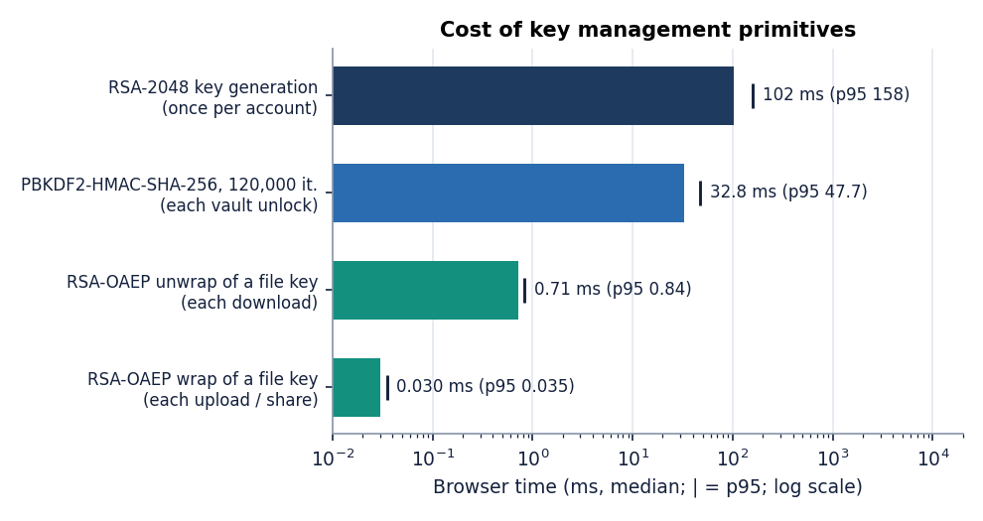
Figure 1: Cost of the key-management primitives in the browser (median, log scale; tick = 95th percentile).
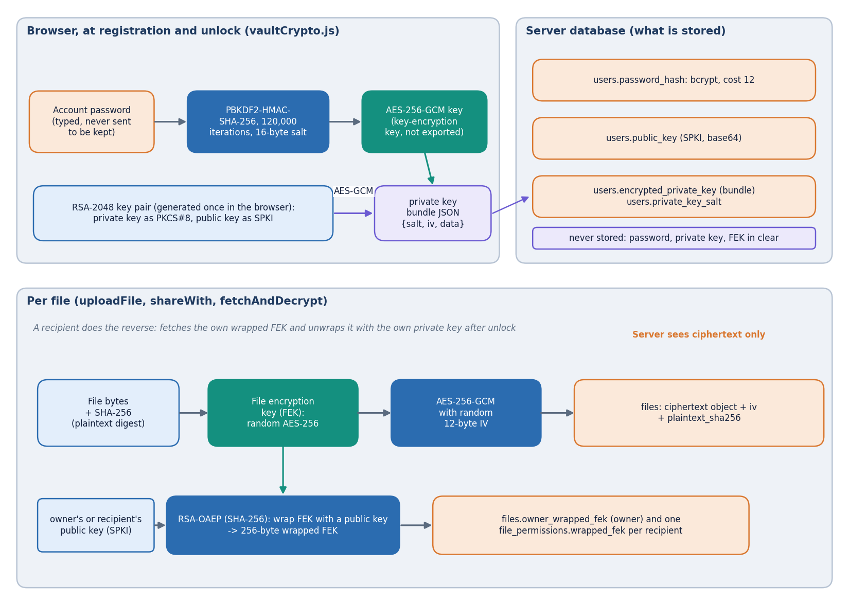
Figure 2: Key hierarchy of CipherVault: password, key-encryption key, private key, wrapped file key and file ciphertext.
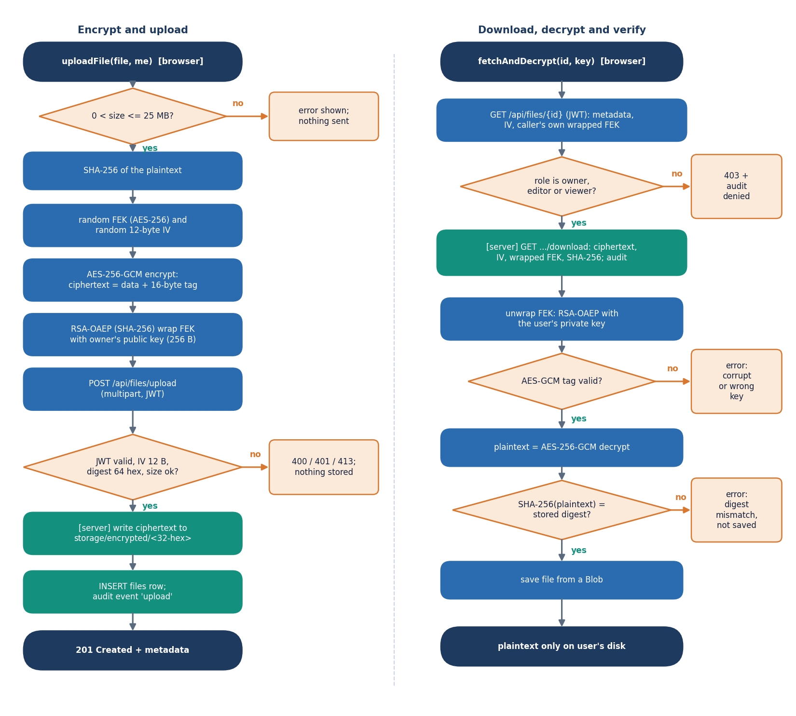
Figure 3: Flowchart of the core algorithm: encrypt-and-upload (left) and download-decrypt-verify (right).

2. NOVELTY AGAINST THE BASE PAPER

2.1 What the base paper contributes
The declared base paper [1] is a scheme for sharing electronic health records through a semi-trusted cloud: ciphertext-policy attribute-based encryption [19] over both user and data attributes, ClinicalBERT [33] to derive the data attributes from clinical notes, several key-generation centres to avoid key escrow, and a private Hyperledger Fabric ledger [34] that holds attribute public keys and policies. Its evaluation is a calculation: the total encryption and decryption cost is built from operation counts and the measured time of each primitive on an HPE server and a Raspberry Pi 3 B+, and no end-to-end system, dataset or extraction accuracy is reported. It is a different system from the one built here, so the comparison below is one of ideas and of method, not of numbers.

2.2 What CipherVault adopts from it
• The same trust model: the cloud store is untrusted and sees only ciphertext.
• A hash of the plaintext is stored and compared after decryption.
• Revocation and the audit of access are treated as part of the design, not extras.
• Cost is reported per cryptographic primitive so that overhead can be understood.

2.3 What is new in CipherVault
CipherVault does not propose a new cryptographic primitive. AES-GCM, RSA-OAEP, PBKDF2, bcrypt and JSON Web Tokens are standard, and each is used as specified. What is new is the integration and the evaluation:
• A deployable, general-purpose encrypted file store. The base paper addresses health records through a calculation; CipherVault is a runnable application with upload, download, replace, delete, sharing, role changes, revocation and a user-visible audit trail, served by a FastAPI back end of 1,184 lines and a React front end of 6,831 lines.
• Browser-side hybrid encryption with per-recipient re-wrapping. Each file is encrypted in the browser with a fresh AES-256-GCM key; that key is wrapped with RSA-2048-OAEP for the owner and, at share time, re-wrapped locally for every recipient, so the server never holds a file key or a private key in usable form. Replacing a file's content re-encrypts under the existing key so every share keeps working.
• Role enforcement on ciphertext. The three roles Owner, Editor and Viewer are checked on the server for every request, while the server only ever stores ciphertext; the access decision and the cryptographic access are separate layers that must both agree.
• A hash-chained audit log with a verification screen. Every sensitive action, including each denied access, is written to a SHA-256 chain that any signed-in user can re-verify from the interface, which stands in for the base paper's ledger at the scale of one application.
• Measured, not calculated, overhead. Cost was measured in Chrome and over loopback on one machine, per primitive and end to end against a plain transfer of the same file (for example a 10 MiB encrypted upload at a median of 209 ms against 194 ms plain), so the reader sees what the user sees rather than a sum of primitive costs.
• A tamper study that finds its own weaknesses. Nine classes of audit-log tampering were tried over 461 real entries: 8 classes were caught in all 1,599 trials, tail truncation was caught in 0 of 199, a rewrite that recomputes the later hashes is not detected, and 100 concurrent failed logins forked the chain. Reporting these limits is part of the contribution.

2.4 What is standard
Galois/Counter Mode [21] on AES [22], SHA-256 [23], RSA-OAEP [24], PBKDF2 [26], [27], bcrypt [28], JSON Web Tokens [29] and the Web Cryptography API [30] are used as published. The three-role model follows the user-role-permission structure of role-based access control [16], [15], and the hash chain is the familiar linked-log idea [31]. The design pattern of an untrusted storage server with client-held keys is older still [10], [11], [12].

2.5 What the base paper and the closest related paper have that CipherVault does not
• No attribute-based encryption, no ClinicalBERT, no multiple key-generation centres and no blockchain. The base paper's fine-grained, policy-in-ciphertext access and its absence of key escrow are not reproduced; CipherVault uses three roles and a server-side check, which is simpler to administer and far cheaper, and which cannot express policies over data content. The base paper calculates the cost of a pairing-free attribute-based scheme in microseconds on a Raspberry Pi and an HPE server; CipherVault measures real uploads, downloads, role checks and audit verification in milliseconds in Chrome and over loopback on an i5-12500 desktop shared with other jobs. The workloads (policy encryption of a record vs. AES-256-GCM of an arbitrary file), the hardware and the metrics differ, so the numbers must not be ranked against each other. Only the qualitative aims (provider-blind storage, integrity check, revocation, auditability) are comparable.
• Features reported by the IJEDR architecture [2] that are absent here. That paper reports TOTP multi-factor sign-in, ECDSA-signed log entries, 4 MB chunking, PBKDF2 with 310,000 iterations (CipherVault uses 120,000) and an S3 and Vault back end. CipherVault has none of these: it encrypts the whole file in memory under a 25 MB cap, has no second factor and keeps ciphertext on the local file system.
• Different headline numbers, different experiments. The IJEDR paper reports +320 ms for a 10 MB upload, 98.6% access-control accuracy over 900 attempts by 50 users and 100% detection of 50 tamper events. CipherVault's matching figures are a measured 14.4 ms difference between medians for a 10 MiB upload on a shared desktop, 36 of 36 role-matrix cells correct (an exhaustive check, not a user study) and 1,599 of 1,599 edits caught in eight classes with a ninth class missed entirely. These are not the same experiments and are not ranked against each other.

3. KEY CONTRIBUTIONS
The contributions of the project, stated at the strength the evidence supports, are:
1. CipherVault, a working encrypted file store: browser-side AES-256-GCM encryption, RSA-2048-OAEP key wrapping per recipient, PBKDF2-protected private keys, Owner / Editor / Viewer roles enforced by a FastAPI service with 24 routes and four database tables, bcrypt and JWT authentication and a React interface (landing, sign-in, dashboard, files, file detail, audit and security pages), with 1,184 lines of back-end code, 6,831 lines of front-end code and 371 lines of tests.
2. A measurement of the cost of client-side encryption: AES-256-GCM, SHA-256, RSA key generation, wrapping and unwrapping and PBKDF2 timed in Chrome from 1 KiB to 25 MiB, and complete upload and download pipelines compared with a plain transfer of the same file (medians 209 against 194 ms for a 10 MiB upload and 184 against 157 ms for the download, with run-to-run spread of up to about three times on a shared machine).
3. An exhaustive check of the access-control rules: four principals against nine operations (36 of 36 cells as expected), unauthenticated requests (5 of 5 rejected) and four kinds of forged token (all rejected), run against the live API.
4. An integrity and tamper study: 2,000 of 2,000 single-bit changes to stored ciphertext rejected by AES-GCM, a wrong key rejected, and nine classes of audit-log tampering tried, with the two undetected cases and the concurrency fault reported.
5. Defects and limits documented, not hidden: tail truncation and consistent rewrite of the audit chain, a forked chain under concurrent writers, a global audit list visible to every signed-in user, no re-keying on revocation, and the same password serving for sign-in and for unlocking the private key, each with the evidence and a proposed fix.
6. A tested, reproducible artefact: 21 passing automated tests, an 17-check API end-to-end run, an 18-step browser walk, a 17-check evaluation script, a metrics script that regenerates every number in the documents, a screenshot script that drives the real interface, and a facts file from which the documents are built.

